**International Islamic University Islamabad**



**Introduction to Database system**

**Project Proposal for Online Shopping Database System**

**Submitted by:**

Noshad Ahmad

**Registration No:**

4107-FBAS/BSSE/F20

**Submitted to:**

Mr. Muhammad Imran Saeed

**\*\*\*\*\*\*\*\*\*\***

**Tables**

**Table 1:**

**Name**: Product

**Attributes:**

1. ID
2. Name
3. Type
4. Size
5. Workman Ship

**1.1 Bubble Chart Diagram for Product table:**

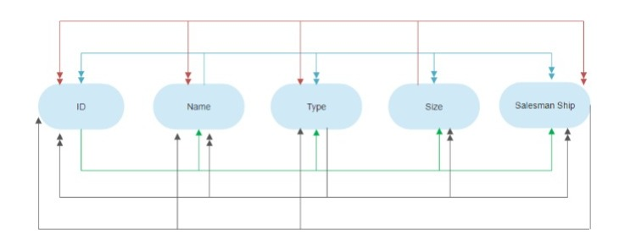

* + 1. **Candidate key:**

Here **ID** is only Candidate key.

* + 1. **Primary key:**

Here **ID** is only Primary key.

* + 1. **Alternate key:**

There is no Alternate key.

* + 1. **Non Key:**

Here **Name, Type**, **Size**,and **Salesman Ship** are non key.

* + 1. **Secondary key:**

Here **Type** is secondary key.

**Table 2:**

**Name**: Customer

**Attributes:**

1. ID
2. Name
3. Phone
4. Address
5. Email

**1.1 Bubble Chart Diagram for Customer table:**

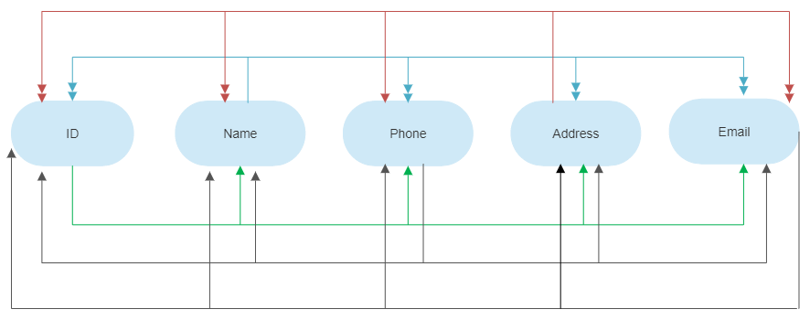

* + 1. **Candidate key:**

Here **ID, Phone** and **Email** is only Candidate key.

* + 1. **Primary key:**

Here **ID** is only Primary key.

* + 1. **Alternate key:**

**Phone** and **Email** is Alternate key.

* + 1. **Non Key:**

Here **Name,** and **Address** are non key.

* + 1. **Secondary key:**

Here **Address** is secondary key.

**Table 3:**

**Name**: Order Detail

**Attributes:**

1. Order ID
2. Product ID
3. Product Name
4. Quantity
5. Cost

**1.1 Bubble Chart Diagram for Order table:**

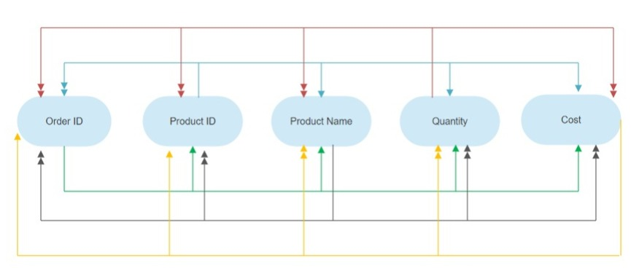

* + 1. **Candidate key:**

Here **Order** **ID** is only Candidate key.

* + 1. **Primary key:**

Here **Order ID** is only Candidate key.

* + 1. **Alternate key:**

There is no Alternate key.

* + 1. **Non Key:**

Here **Product ID, Product Name**, **Quantity**,and **Cost** are non key.

* + 1. **Secondary key:**

There is no secondary key.

**Table 4:**

**Name**: Order

**Attributes:**

1. Order ID
2. Date
3. Customer ID
4. Status

**1.1 Bubble Chart Diagram for Order table:**

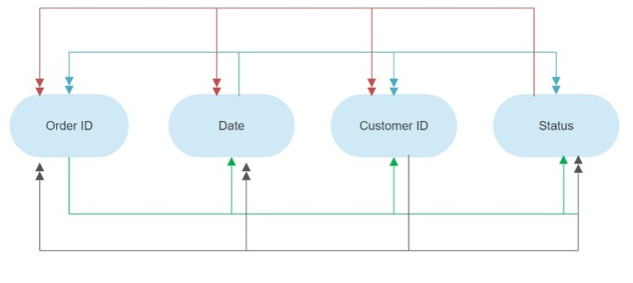

**1.1.1 Candidate key:**

Here **ID** is only Candidate key.

* + 1. **Primary key:**

Here **ID** is only Candidate key.

* + 1. **Alternate key:**

There is no Alternate key.

* + 1. **Non Key:**

Here **Date**, **Customer ID** and **Status** are non key.

* + 1. **Secondary key:**

Here **Date** is secondary key.

**Table 5:**

**Name**: User

**Attributes:**

1. User ID
2. Password
3. Login Status

**1.1 Bubble Chart Diagram for User table:**

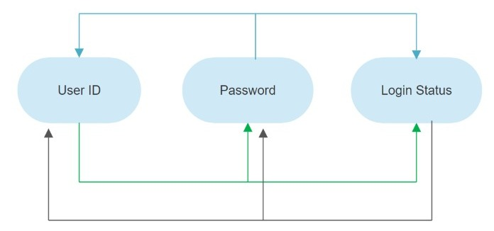

* + 1. **Candidate key:**

Here **ID** and **Password** Candidate key.

* + 1. **Primary key:**

Here **ID** is Candidate key.

* + 1. **Alternate key:**

There is **Password** Alternate key.

* + 1. **Non Key:**

Here **Login Status** is non key.

* + 1. **Secondary key:**

There is no secondary key.